# 

**OOP Lab Assignment**

**Name: M. Abdullah Aslam**

**Registration Number: SP24-BSE-028**

**Section: BSE_A**

**Submitted to: Sir Shahid Bhatti**

Data Entry Form

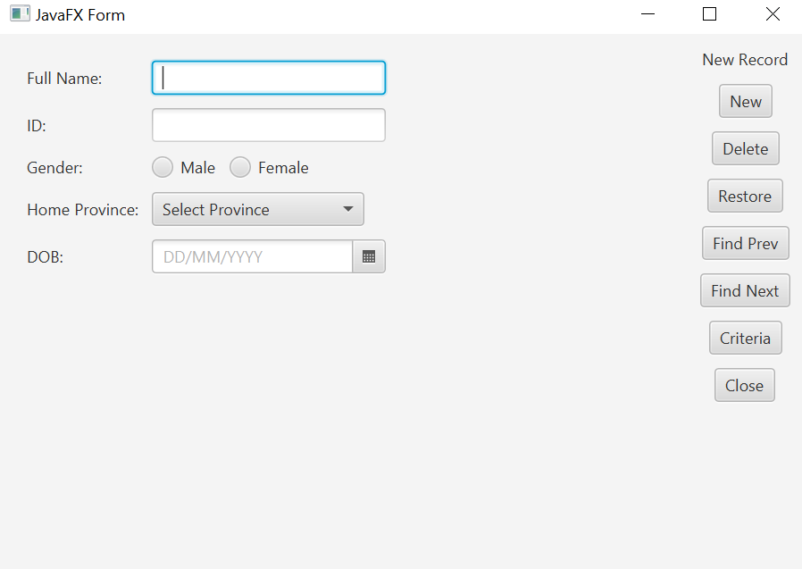

**Gender Radio Button Code:**

RadioButton maleRadio = new RadioButton("Male");  
RadioButton femaleRadio = new RadioButton("Female");  
maleRadio.setToggleGroup(genderGroup);  
femaleRadio.setToggleGroup(genderGroup);  
HBox genderBox = new HBox(10, maleRadio, femaleRadio**);**

**Combo Box for Province Selection Code:**

ComboBox<String> provinceBox = new ComboBox<>();  
provinceBox.getItems().addAll("Sindh", "Punjab", "Balochistan", "Khyber Pakhtunkhwa", "Gilgit-Baltistan");  
provinceBox.setPromptText("Select Province");

**Date of Birth picker Code:**

DatePicker dobPicker = new DatePicker();  
dobPicker.setPromptText("DD/MM/YYYY");

**File Handling and new Button Code:**

Button newButton = new Button("New");  
newButton.setOnAction(e -> {  
 String fullName = fullNameField.getText();  
 String id = idField.getText();  
 String gender = genderGroup.getSelectedToggle() == null ? null : ((RadioButton) genderGroup.getSelectedToggle()).getText();  
 String province = provinceBox.getValue();  
 LocalDate dob = dobPicker.getValue();  
  
 if (fullName.isEmpty() || id.isEmpty() || gender == null || province == null || dob == null) {  
 showAlert(Alert.AlertType.*ERROR*, "Form Error!", "Please complete all fields.");  
 return;  
 }  
  
**File Handling:**

File file = new File("form_data.txt");  
 try (BufferedWriter writer = new BufferedWriter(new FileWriter(file, true))) {  
 writer.write("Full Name: " + fullName);  
 writer.newLine();  
 writer.write("ID: " + id);  
 writer.newLine();  
 writer.write("Gender: " + gender);  
 writer.newLine();  
 writer.write("Home Province: " + province);  
 writer.newLine();  
 writer.write("DOB: " + dob.toString());  
 writer.newLine();  
 writer.write("----------------------------");  
 writer.newLine();  
  
 showAlert(Alert.AlertType.*INFORMATION*, "Success", "Data saved successfully!");  
  
 fullNameField.clear();  
 idField.clear();  
 genderGroup.selectToggle(null);  
 provinceBox.setValue(null);  
 dobPicker.setValue(null);  
 } catch (IOException ex) {  
 showAlert(Alert.AlertType.*ERROR*, "File Error!", "Unable to write to file.");  
 }  
});

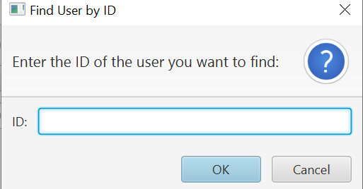

**Find by user Id:**

Button findPrevButton = new Button("Find Prev");  
findPrevButton.setOnAction(e -> {  
  
 TextInputDialog idDialog = new TextInputDialog();  
 idDialog.setTitle("Find User by ID");  
 idDialog.setHeaderText("Enter the ID of the user you want to find:");  
 idDialog.setContentText("ID:");

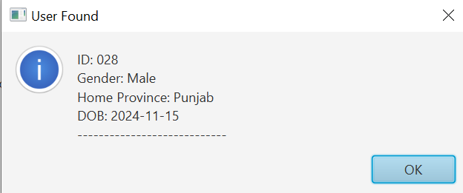

**Data of The founded user Code:**

idDialog.showAndWait().ifPresent(userID -> {  
  
  
 File file = new File("form_data.txt");  
 try (BufferedReader reader = new BufferedReader(new FileReader(file))) {  
 String line;  
 StringBuilder userData = new StringBuilder();  
 boolean userFound = false;  
  
 while ((line = reader.readLine()) != null) {  
 if (line.contains("ID: " + userID)) {  
 userFound = true;  
 userData.append(line).append("\n");  
  
 for (int i = 0; i < 4; i++) {  
 userData.append(reader.readLine()).append("\n");  
 }  
 break;  
 }  
 }  
  
 if (userFound) {  
  
 showAlert(Alert.AlertType.*INFORMATION*, "User Found", userData.toString());  
 }

catch (IOException ex) {  
 showAlert(Alert.AlertType.*ERROR*, "File Error!", "Unable to read from file.");  
 }  
 });  
});

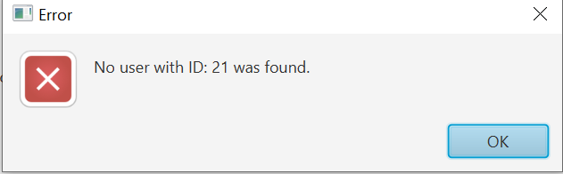

If the user not found in the file following code is responsible for the above window:

} else {  
  
 showAlert(Alert.AlertType.*ERROR*, "Error", "No user with ID: " + userID + " was found.");  
 }

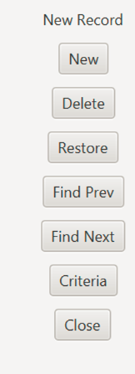**Code for the menu:**

Label newRecordLabel = new Label("New Record");  
Button deleteButton = new Button("Delete");  
Button restoreButton = new Button("Restore");  
Button findNextButton = new Button("Find Next");  
Button criteriaButton = new Button("Criteria");  
Button closeButton = new Button("Close");

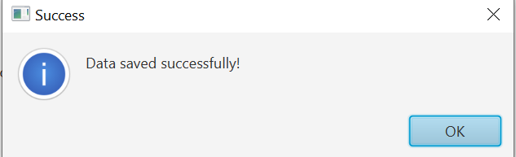

**Code for above window:**

showAlert(Alert.AlertType.*INFORMATION*, "Success", "Data saved successfully!");